**PILOT CASE: ÇAMLIK DISTRICT**

**Introduction**

In the Ankara case study, we focus on a gated community composed of low-rise housing units, namely, “Çamlık District.” The end goal of the project is to investigate the possibility of transforming the district into a Positive Energy District (PED).

**Local Context**

Çamlık District stands within the boundaries of 100. Yıl neighborhood, which constitutes a relatively engaged community of inhabitants. The user group of 100. Yıl neighborhood is a diverse one that is mainly composed of students, elderly, and middle-aged working people. The neighborhood is known for its local bazaar and local-scale events that promote a circular economy.

Çamlık District is located within the city of Ankara, the capital city of Türkiye. Ankara is a crowded metropolis (over 8 million inhabitants) that has multiple city centers and sub-centers. As a result, different regions have different socio-political characteristics that inevitably affect the regional context and the built environment. Çankaya, the district in which Çamlık District is located, is a region that inhabits well-established built environments in comparison with many other regions of the city. As an example of environmentally responsible municipalism, Çankaya Municipality established a recent directorate named “Climate Change and Zero Waste Directory.” The directorate defines its main aim as “...preventing the deterioration, degradation, and destruction of environmental values and ecological balance, eliminating existing deteriorations, improving and developing the environment, and carrying out studies to prevent environmental pollution.” The Directorate has a wide range of completed projects that mainly focus on increasing greenery and vegetation within the region.

Ankara also has a climate change action plan prepared by the municipality (Ankara Buyuksehir Belediyesi, 2022). The comprehensive action plan covers a wide span of improvements on various notions. The document begins by introducing the juxtaposition area of climate change and Ankara, highlighting the necessity for a change in the built environment. A visible statement of the document lies within the analyses it provides on the effects of greenhouse gas emissions on notions of population, gross domestic product, economy, and energy. Illustrating the potential regulations for lowering emissions, the document critically evaluates the built environment and the transportation sector. Some of the regulations concerning the built environment are: retrofitting the existing municipal buildings, auditing the new constructions via green building standards, eliminating coal usage for heating, financial incentives towards increasing energy performances of existing buildings, and dissemination studies on energy efficiency.

**National Context**

Turkiye is an ever-developing country. The growing concerns about climate change have led the country to participate in worldwide agreements and take measures, as it is considered one of the countries unfavorably affected by climate change; thus, it is listed among high-risk countries (Yildirim & Gurkan, 2016). Turkiye is aware of the climatic risks, and as a result, the Ministry of Environment and Urbanization was renamed the Ministry of Environment, Urbanization, and Climate Change on October 29, 2021, to address the issue at the governmental level. A ground example of the theme is the signing of the Paris Agreement in 2016 followed by a Presidential Approve in 2021. In accordance with the terms of the agreement, Türkiye aims to decrease its greenhouse gas (GHG) emissions by 21% by 2030 and reach net zero by 2053 (Kat et al., 2018). At the national level, the Directorate of Climate Change has recently unveiled a strategic plan covering 2024 to 2028, alongside initiatives at the municipal level. Specific cities are formulating action plans and strategies for both mitigating and adapting to climate change, which are being implemented through constitutional measures and actions at the municipality scale (Tuğaç, 2021). Another significant document recently published is the “Climate Change Reduction Strategies and Action Plan” published by the Directorate of Climate Change (2024). The document illustrates the current status of the nation regarding the effects of climate change in detail, followed by further structured strategies for adaptation and mitigation towards it. Inclusive of a variety of fields such as energy, agriculture, industry, and many more, the document brings about strategies that engage citizens, NGOs, local governments, and commercial structures together. In The Climate Change Performance Index (CCPI), an independent monitoring tool for tracking climate change protection performance of countries, published for the year 2024 (Bosse, 2023), Turkiye, despite having fallen 9 places since 2023, has demonstrated its determination in climate change actions by increasing the pledged greenhouse gas (GHG) reduction from 21% to 41% with the new plan (Directorate of Climate Change, 2024).

The EU and Turkiye jointly finance numerous projects to fight against the negative effects of climate change, with the Ministry of Environment, Urbanization, and Climate Change in Turkey serving as the beneficiary institution. The ministry offers financial and technical assistance to local organizations, engaging a wide array of stakeholders, including municipalities, universities, and non-governmental organizations (Guler & Kumar, 2022). Moreover, 14 municipalities in Türkiye, 4 of which are metropolitan municipalities, are members of Local Governments for Sustainability-ICLEI. Additionally, the “Climate Agreement of Mayors,” a letter of agreement that came into force in 2017, was signed by 13 county municipalities and 23 district municipalities (Dogru & Bagatır, 2021). These 36 local governments aim to achieve the goals of reducing/limiting greenhouse gas emissions, preparing for the defects of climate change, allocating resources for sustainable energy, and developing policies in line with these goals that will foster implementation and monitoring. Empowered by the local governments, Turkiye is excelling in mitigating climate change.

**Pilot Site**

Çamlık District is located near Middle East Technical University. The building stock of 257 single housing units is mainly occupied by families. The user group of Çamlık District is mainly composed of people with an educational background, some of which originate directly from METU. Consequently, the community is self-aware, willing to participate in climate change actions, and eager for citizen engagement.

The region is subject to a continental climate. However, owing to the ever-increasing temperatures, recent summers have been relatively hotter and drier, whereas winters have been warmer with much less snowfall.

**Data Sources**

In order to create a database for modeling applications, certain amounts and various types of data have been collected from the site. The building footprints are obtained from 2D drawings (.dwg files) of Ankara. Building properties are obtained via aerial photographs, on-site observations, and documentation.

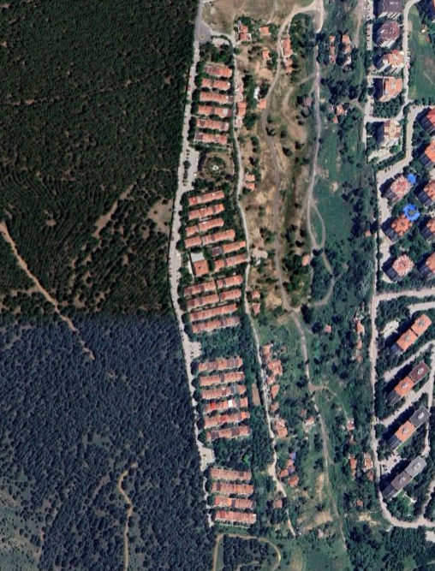

Figure 1: Aerial photograph of Çamlık District

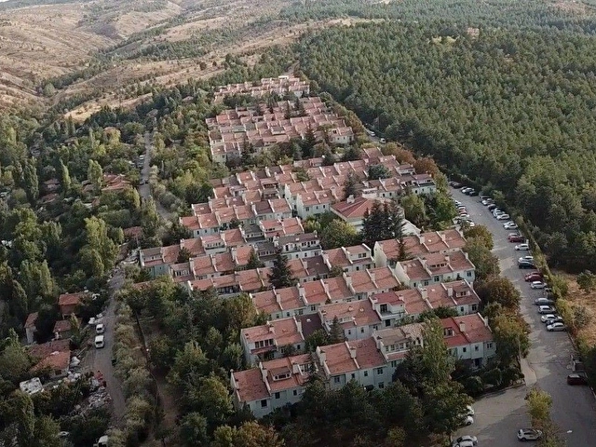

Figure 2: Aerial photograph of Çamlık District

**Building Properties**

The district constitutes a low-rise regional plan with fair amounts of green areas and vegetation. Coupled with its unique community engagement, Çamlık District resembles a rather European district and is, therefore, well-fitting for research purposes.

Buildings have been constructed in a relatively recent time period. They have the entrance floor, the second floor that includes a balcony, and an attic floor, which in some cases are upgraded by fenestration units. The buildings are designed and constructed with a reinforced concrete system and completed with partition walls.

The houses are privately owned or rented, mainly by families. The district is composed of approximately 50.800 m2 total area and 22.600 m2 conditioned area. There are 257 residential buildings and a central building in which social gatherings and events are held. Table 1 depicts a comprehensive review of the site.

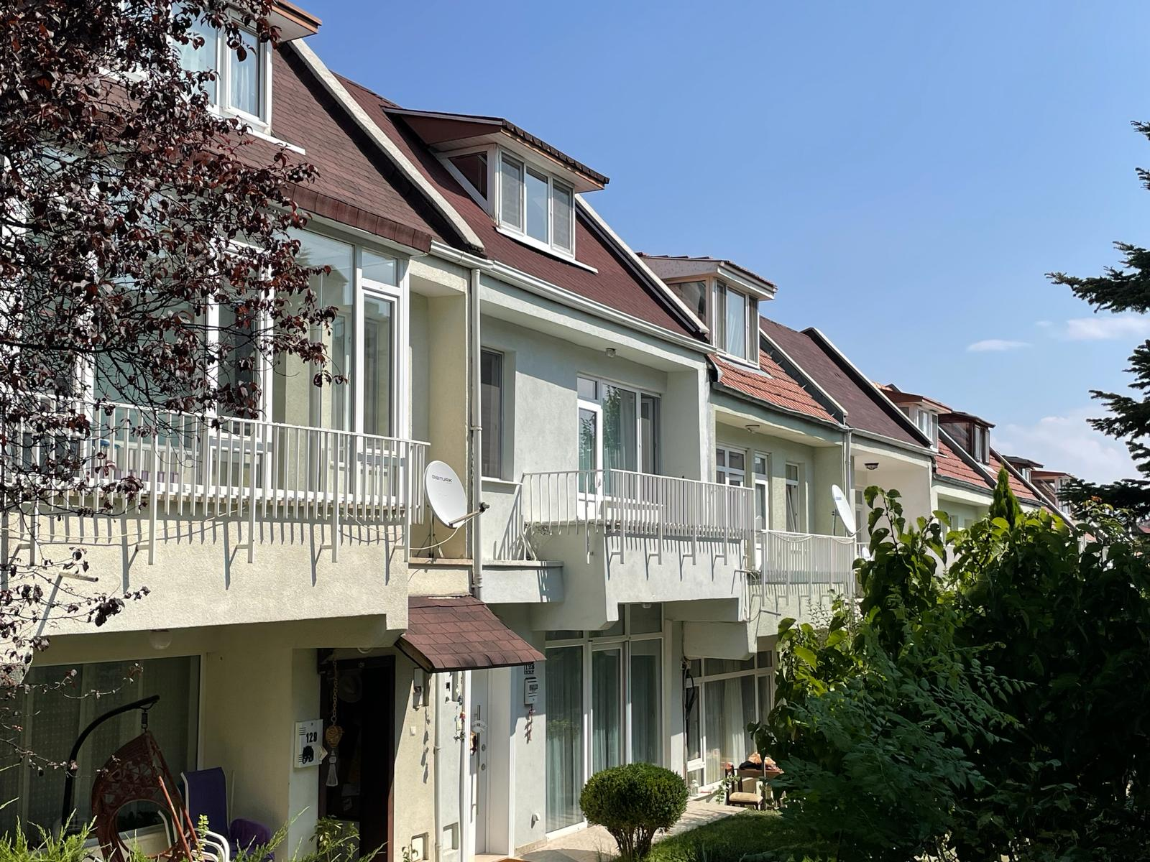

Figure 3: Image of housing units in Çamlık District

|  |  |  |  |  |  |
| --- | --- | --- | --- | --- | --- |
| **Applications of Renewable Energy/Energy Efficiency** | **Ownership of the district; Ownership of the land/infrastructure** | **Land Use Context** | **Type of District; District Context** | **Total ground area Conditioned Space Number of Buildings Floor area ratio** | **Social Models** |
| Solar  (on site),  heat pump (on-site) | Private  Single | Residential | Renovation Retrofitting Area | 50.800 m2 total area  22.600 m2 conditioned area  257 residential buildings and 1 central building  52% | Bottom-up approach |

Table 1: Summary of information regarding Çamlık District

**Methodology**

The methodological framework of the study consists of four main steps. First, a baseline model is created to calculate the initial demands. Following that, the façade configurations were modeled according to the recent Turkish standards, which consisted of the fundamentals of step 2. Consequently, a heat pump model was integrated into the energy model for step 3 in order to lower the heating demand. Finally, a photovoltaic panel model was integrated into the energy model in order to compare and contrast potential energy generation to energy demand.

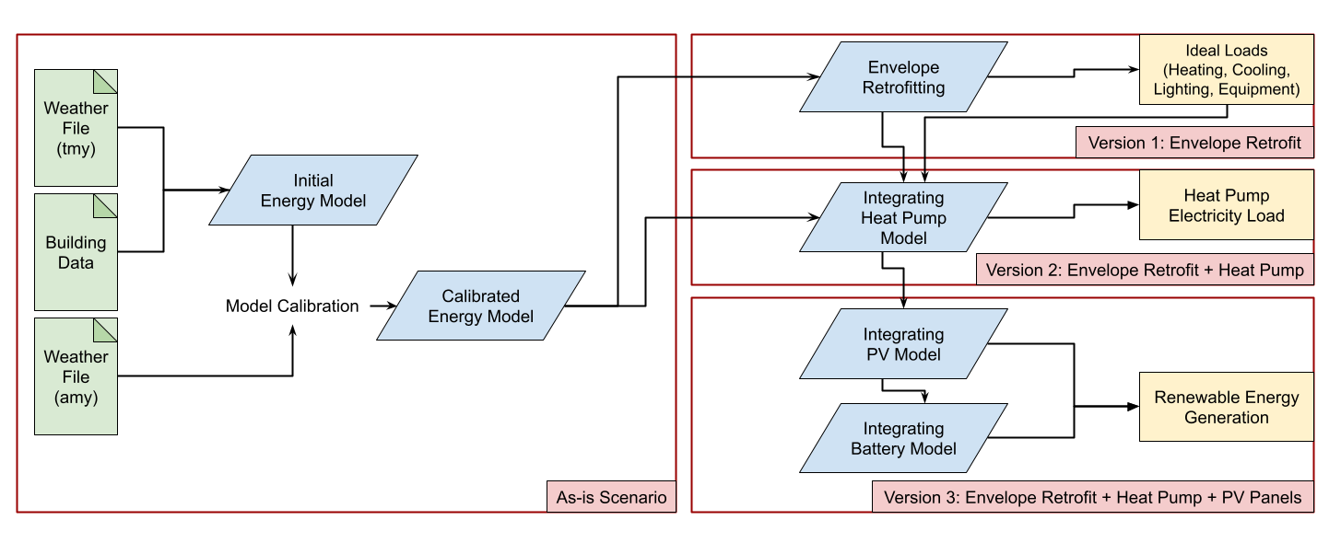

Figure 4: Methodology Chart

**Co-learning Process and Strategies**

In order to achieve cooperation with the inhabitants, a number of steps were taken. Firstly, a meeting between the project partners and the administrative board of Çamlık District was realized in the consortium of the PED-ACT project. The executive organs of the project came together with the board to discuss the scope and aim of the project and the means of contribution it could bring about. Following this initial meeting, a second interaction was organized by the PED-ACT METU Team, in which a comprehensive presentation of the project was presented to the community members. Subsequently, a survey was created to obtain further data regarding the buildings, energy usage, natural gas and electricity bills, and schedules.

**References**

Ankara Buyuksehir Belediyesi. (2022). *Ankara Iklim Degisikligi Yerel Eylem Plani*.

Bosse, J. (2023, December 8). Turkey – Climate performance ranking 2024 | Climate Change Performance Index. Climate Change Performance Index | the Climate Change Performance Index (CCPI) Is a Scoring System Designed to Enhance Transparency in International Climate Politics. https://ccpi.org/country/tur/#:~:text=Turkey%20drops%20nine%20ranks%20in,very%20low%20in%20Climate%20Policy.

Directorate of Climate Change. (2024). 2024 - 2028 Stratejik Plan (Ministry of Environment, Urbanization, and Climate Change).

Directorate of Climate Change. (2024). Iklim Degisikligi Azaltim Stratejisi ve Eylem Plani. (Ministry of Environment, Urbanization, and Climate Change).

Guler, Y., & Kumar, P. (2022). Climate change policy and performance of Türkiye in the EU harmonization process. Frontiers in Sustainable Cities, 4, 1070154.

*Iklim Degisikligi ve Sifir Atik Mudurlugu*. Cankaya Belediyesi. https://www.cankaya.bel.tr/pages/106/Cevre-Koruma-ve-Kontrol-Mudurlugu/

Iklim Degisikligi Baskanligi. (2024). *2024 - 2028 Stratejik Plan.*

Kat, B., Paltsev, S., and Yuan, M. (2018). Turkish energy sector development and the Paris Agreement goals: a CGE model assessment. Energy Policy 122, 84–96. doi: 10.1016/j.enpol.2018.07.030

Dogru, B., & Bagatir, B. (2021). *Iklimin kentlesmesi ve Yerel i̇klim Eylem Planlari*. İklim Haber. https://www.iklimhaber.org/iklimin-kentlesmesi-ve-yerel-iklim-eylem-planlari/

Şen, Z. (2022). *Iklim Degisikligi ve Türkiye*, Cevre, Sehir ve Iklim Dergisi. Year: 1. Issue: 1. p. 1-19.

Tuğaç, Ç. (2021). Kentsel sürdürülebilirlik, dirençlilik ve iklim değişikliğiyle mücadele bağlamında yerel yönetimler üzerine bir değerlendirme. *Çağdaş Yerel Yönetimler*, *30*(2), 21-69.

Yildirim, M., and Gurkan, H. (2016). Türkiye icin iklim degisikligi projeksiyonlari. Uluslararasi Katilimli 2. Vol. 2. Sanliurfa: Iklim Degisimi ve Tarim Etkilesimi Calistayi.